Activity Diagrams

# Landing Page

The main page for information regarding how to use the tool, with links leading to the other pages. The page also links to the GitHub page with a more technical readme.

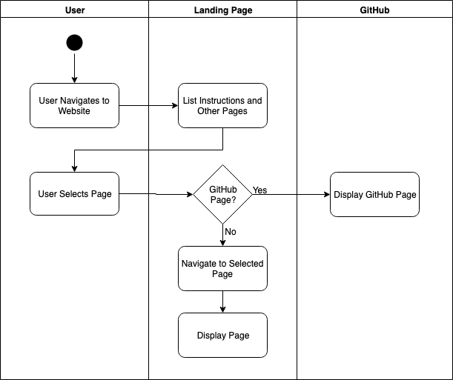

# Navigation Page

The Navigation page gives a short description of what the page is for and how to use it. From here, users can select where they are and where they’d like to go, then calculate the shortest route.

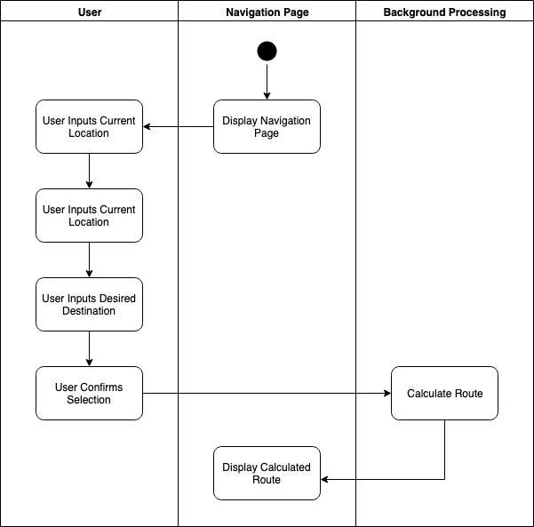

# Cardio Route Page

The Cardio Route page will allow the user to calculate a route for their desired form of cardio exercise (e.g., running, jogging, or biking).

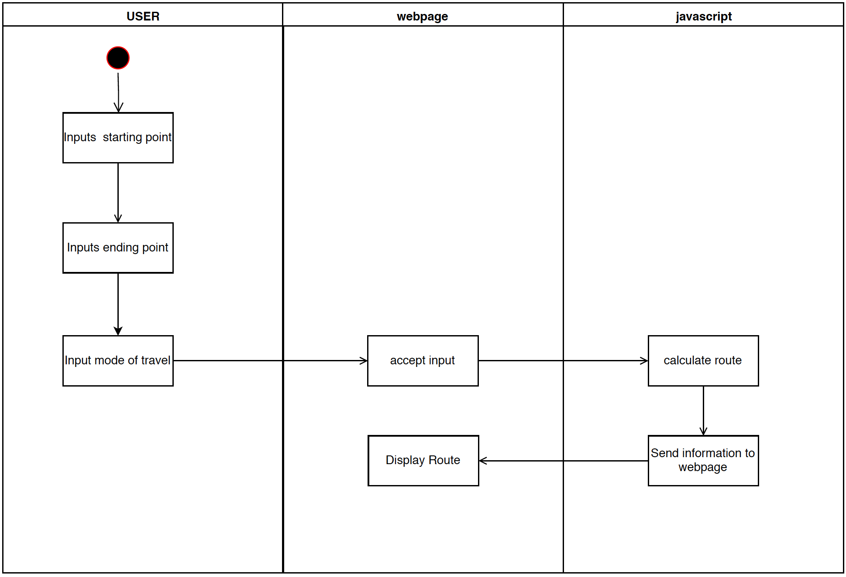

# Points of Interest Page

The Points of Interest page will allow the user to search for and/or select a more specific location (e.g., restroom, vending machines, student services office).

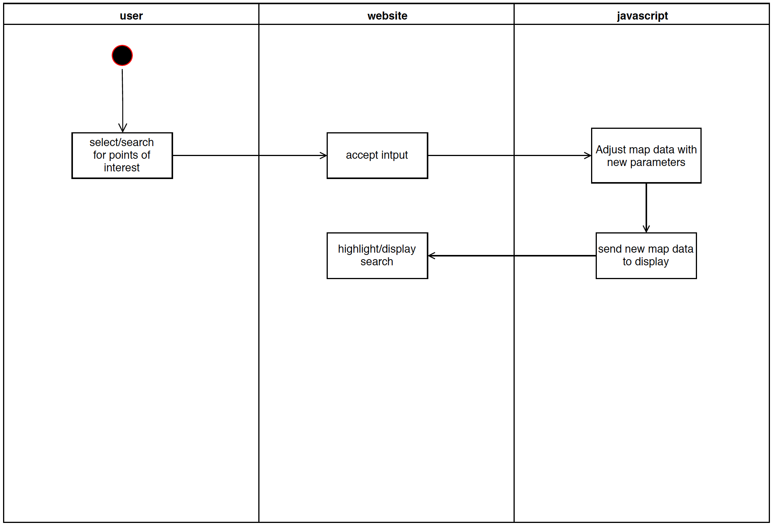

Structural Model

# Class Diagram

The main attributes and operations for each class.

Behavioral Models

# Sequence Diagram: Navigation

Sequence diagram that depicts interaction between user, WSUV Map, and database to route from a start point to a destination point.

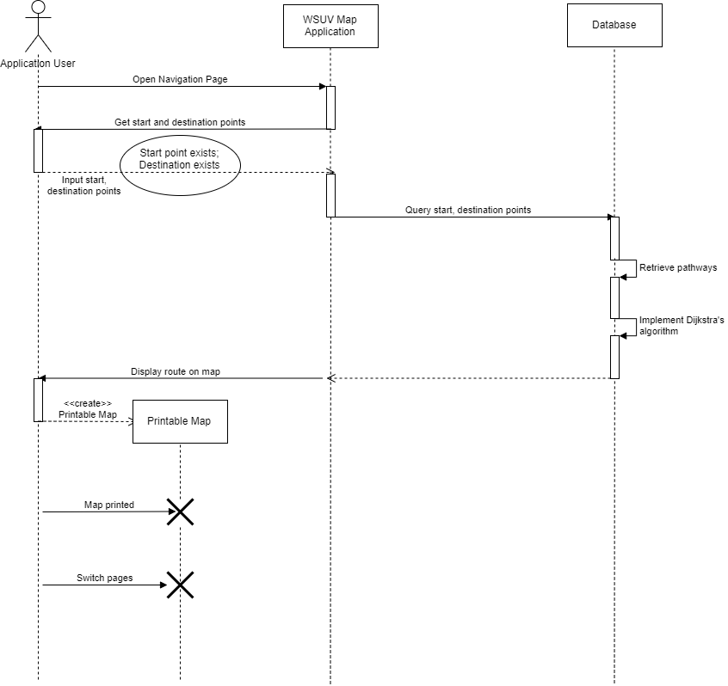

# Sequence Diagram: Cardio

Sequence diagram that depicts interaction between user, WSUV Map, and database to create a cardio route loop near a designated start point.

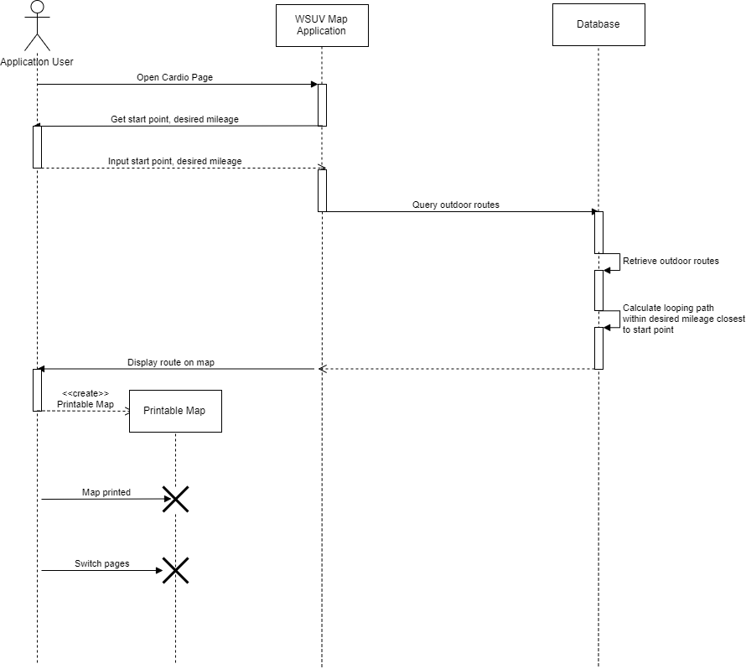

# State Diagram: Pages

State diagram that depicts transitions between WSUV Map pages.

